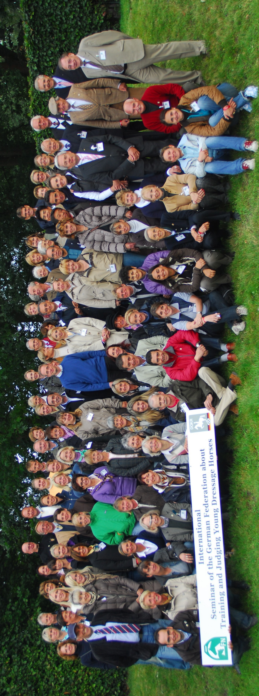

The German Equestrian Federation, will for the third time, host an International Dressage Seminar in Warendorf. The focus of the 4-day seminar will - once again - be the training and judging of young dressage horses. The seminar will take place during the ‘DKB Bundeschampionate’ (German National Championships for young horses) and is addressed at judges, trainers, stewards, veterinarians and interested horsemen and women. During the first two days the participants will have the opportunity to view competitions involving 4-year old stallions as well as 5 and 6 year old dressage horses. Participants will be able to hear commentary for all riders and there will be the opportunity for discussion afterwards. From the third day onwards the focus of the seminar will be theory based, combined with some specific practical examples. The participants will be guided by well-known dressage experts; Dr. Schüle (GER), Stephen Clarke (GBR), Gishlain Fouarge (NED) and Christoph Hess (GER). Additionally some specialist trainers and contributors will be invited to add content towards special subjects. The dressage trainers and their riding pupils of the German Olympic Committee for Equestrian Sports will be responsible for the practical part of the seminar.

Kontakt: cbrueggemann@fn-dokr.de

**Young Horses Seminar in Warendorf**

**02. – 05. 09. 2017**